Day-2 Assignment
Q1. List 3 real-world devices in your home or college that use SMPS (Switched Mode Power Supply) and 2 devices that use UPS (Uninterruptible Power Supply), explaining in one line why each device needs that type of power supply.
Ans.
Devices Using SMPS and UPS
1. Devices That Use SMPS (Switched Mode Power Supply)
No. | Device | Why It Uses SMPS
1 | Desktop Computer | Converts AC power into the regulated DC voltages required by computer components.
2 | Laptop Charger | Converts AC electricity from the wall socket into suitable DC power for the laptop.
3 | LED TV | Converts input power into the stable DC voltages needed by its electronic circuits.
2. Devices That Use UPS (Uninterruptible Power Supply)
No. | Device | Why It Uses UPS
1 | Desktop Computer | Provides temporary backup power during a power cut, allowing the user to save work and shut down safely.
2 | Wi-Fi Router | Keeps the internet connection running temporarily during a power interruption.

Q2. Draw and label a diagram showing the main internal components of a typical SMPS unit found in a desktop PC, including AC input, rectifier, transformer, and DC output sections(Hint: You can hand-draw and upload a photo, or use any free diagram tool like draw.io.)
Ans.
Labeled Diagram: Internal Components of a Desktop PC SMPS
The following block diagram shows how a desktop computer's SMPS (Switched Mode Power Supply) converts AC input electricity into regulated DC output power.

1. AC Input
230 V AC from wall socket
↓
2. EMI Filter
Reduces electrical noise and interference
↓
3. Rectifier and Filter
Converts AC into high-voltage DC
↓
4. Switching Circuit
Switches DC at high frequency
↓
5. High-Frequency Transformer
Transfers energy and provides isolation
↓
6. Secondary Rectifier and Filter
Converts high-frequency output into DC
↓
7. DC Output
+3.3 V, +5 V, +12 V DC
To motherboard, CPU, drives and other components
Main components and their functions
Component | Function
AC input | Receives electricity from the mains supply.
EMI filter | Reduces electrical interference.
Rectifier | Converts AC into DC.
Switching circuit | Converts the DC into high-frequency pulses.
Transformer | Transfers energy and provides electrical isolation.
Secondary rectifier and filter | Produces smoother DC output voltages.
DC output section | Supplies regulated power to computer components.

Q3. Take photos or find clear images online of the following power connectors: ATX 24-pin motherboard connector, SATA power connector, Molex connector, and PCIe 6/8-pin connector. For each, write its name, the devices it powers, and one safety tip for connecting/disconnecting it.
Ans.
PC Power Connectors: Images, Uses, and Safety Tips
These four connectors are commonly found inside desktop PC power supplies (SMPS). For your assignment, identify each connector, describe the devices it powers, and mention one safety precaution.
1. ATX 24-pin motherboard connector
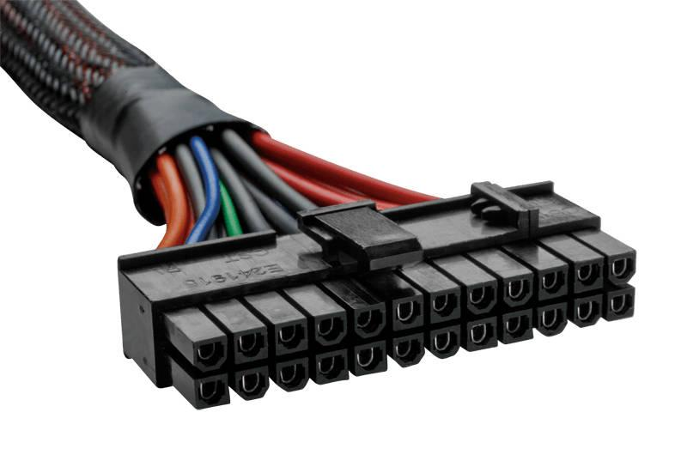
- Name: ATX 24-pin motherboard power connector
- Devices powered: The motherboard and its power-distribution circuits.
- Safety tip: Switch off and unplug the computer before connecting or disconnecting it. Align the locking clip and never force the connector.
2. SATA power connector
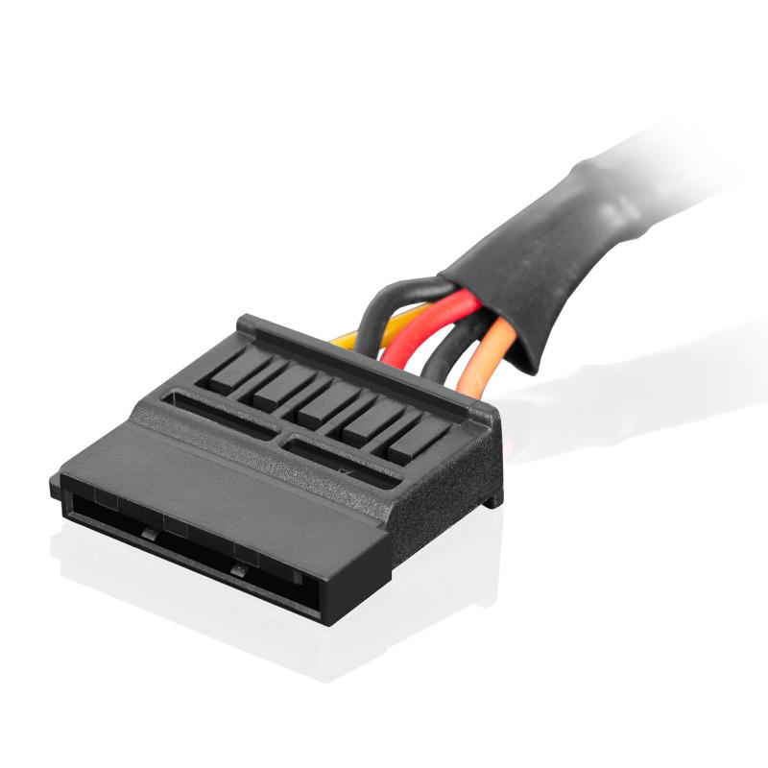
- Name: SATA power connector (15-pin)
- Devices powered: SATA hard disk drives (HDDs), solid-state drives (SSDs), optical drives, and some RGB controllers.
- Safety tip: Align the L-shaped connector carefully and pull it out by the plastic connector, not by the wires.
3. Molex connector
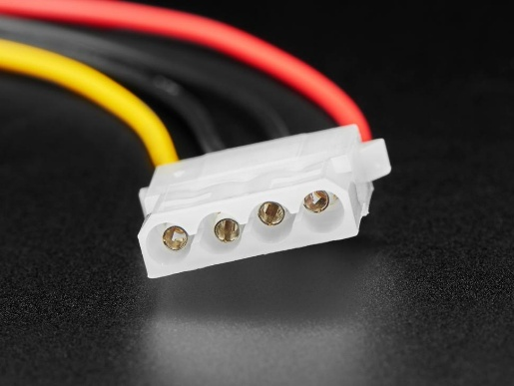
- Name: 4-pin Molex peripheral power connector
- Devices powered: Older hard drives, CD/DVD drives, and some computer case fans.
- Safety tip: Disconnect the computer from the power supply first, and gently wiggle the connector while pulling it out; never pull on the wires.
4. PCIe 6/8-pin connector
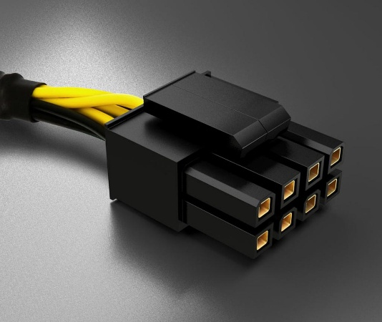
- Name: PCIe 6-pin / 8-pin (6+2-pin) power connector
- Devices powered: Compatible dedicated graphics cards (GPUs) that require additional power.
- Safety tip: Use the correct PCIe cable, not the similar-looking CPU power cable, and ensure the connector is fully seated before turning on the computer.
Summary table
Connector | Main device powered | Safety precaution
ATX 24-pin | Motherboard | Unplug power and align the latch.
SATA power | HDD, SSD, optical drive | Align the L-shaped connector.
Molex 4-pin | Older drives and some fans | Pull the plastic plug, not the wires.
PCIe 6/8-pin | Compatible graphics card | Use the correct PCIe cable.
General safety: Always shut down and unplug the PC before handling internal power connectors. Never force a plug into a socket.

Q4. Imagine you are setting up a new gaming PC. List the steps you would follow to connect the SMPS to the motherboard, graphics card, and storage devices, mentioning which specific cables and connectors are used for each.
Ans.
Procedure to Connect SMPS in a Gaming PC
The SMPS (Switched Mode Power Supply) supplies power to the motherboard, graphics card, and storage devices. The following steps explain how to connect each component safely.
Step-by-step instructions
Step 1: Install the SMPS
- Switch off and unplug the computer from the wall socket.
- Place the SMPS in the designated area inside the PC case.
- Secure it using screws.
Step 2: Connect the motherboard
- Locate the 24-pin ATX power connector on the motherboard.
- Connect the 24-pin cable from the SMPS to the motherboard.
- Press gently until the locking clip clicks into place.
Step 3: Connect CPU power
- Locate the CPU power socket near the processor.
- Connect the 4+4-pin CPU/EPS power cable from the SMPS.
- This supplies power to the CPU's power circuitry.
Step 4: Connect the graphics card
- Insert the graphics card into the appropriate PCIe slot.
- Connect the required PCIe 6-pin, 8-pin (6+2-pin), or 12V-2x6 power cable, depending on the graphics card model.
- Ensure the connector is fully seated.
Step 5: Connect storage devices
- For a SATA HDD or SSD, connect the 15-pin SATA power cable from the SMPS.
- Connect a separate SATA data cable between the drive and motherboard.
- An M.2 NVMe SSD installed in its motherboard slot generally requires no separate power cable.
Step 6: Check all connections
- Verify that all power connectors are firmly attached.
- Keep cables away from fans and other moving parts.
- Close the case before reconnecting the power supply and testing the computer.
Summary table
Component | Cable / Connector | Purpose
Motherboard | 24-pin ATX | Supplies main motherboard power.
CPU power socket | 4+4-pin CPU/EPS | Supplies power to the CPU power circuitry.
Graphics card | PCIe 6-pin / 8-pin or 12V-2x6 | Supplies additional GPU power.
SATA HDD or SSD | 15-pin SATA power | Supplies electrical power to the drive.
SATA HDD or SSD | SATA data cable | Transfers data between the drive and motherboard.
M.2 NVMe SSD | Motherboard M.2 slot | Provides the drive's connection and power.
Safety precautions:
- Always unplug the computer before handling internal components.
- Never force a connector into a socket.
- Use only modular PSU cables confirmed compatible with your exact power supply model.

